Create Skills and Portfolio Sections
Send Feedback

Now that you have been given some idea of how to create skills section, you have to create it completely.

Similarly, you can also try to build the portfolio section. The needed files are provided inside the assets.

Inside the portfolio section, on hovering over the images there should be some text that appears on the images with lightgrey background color. (You can see this in one of the images in the portfolio section)

The resume after skills and portfolio section will look like this -

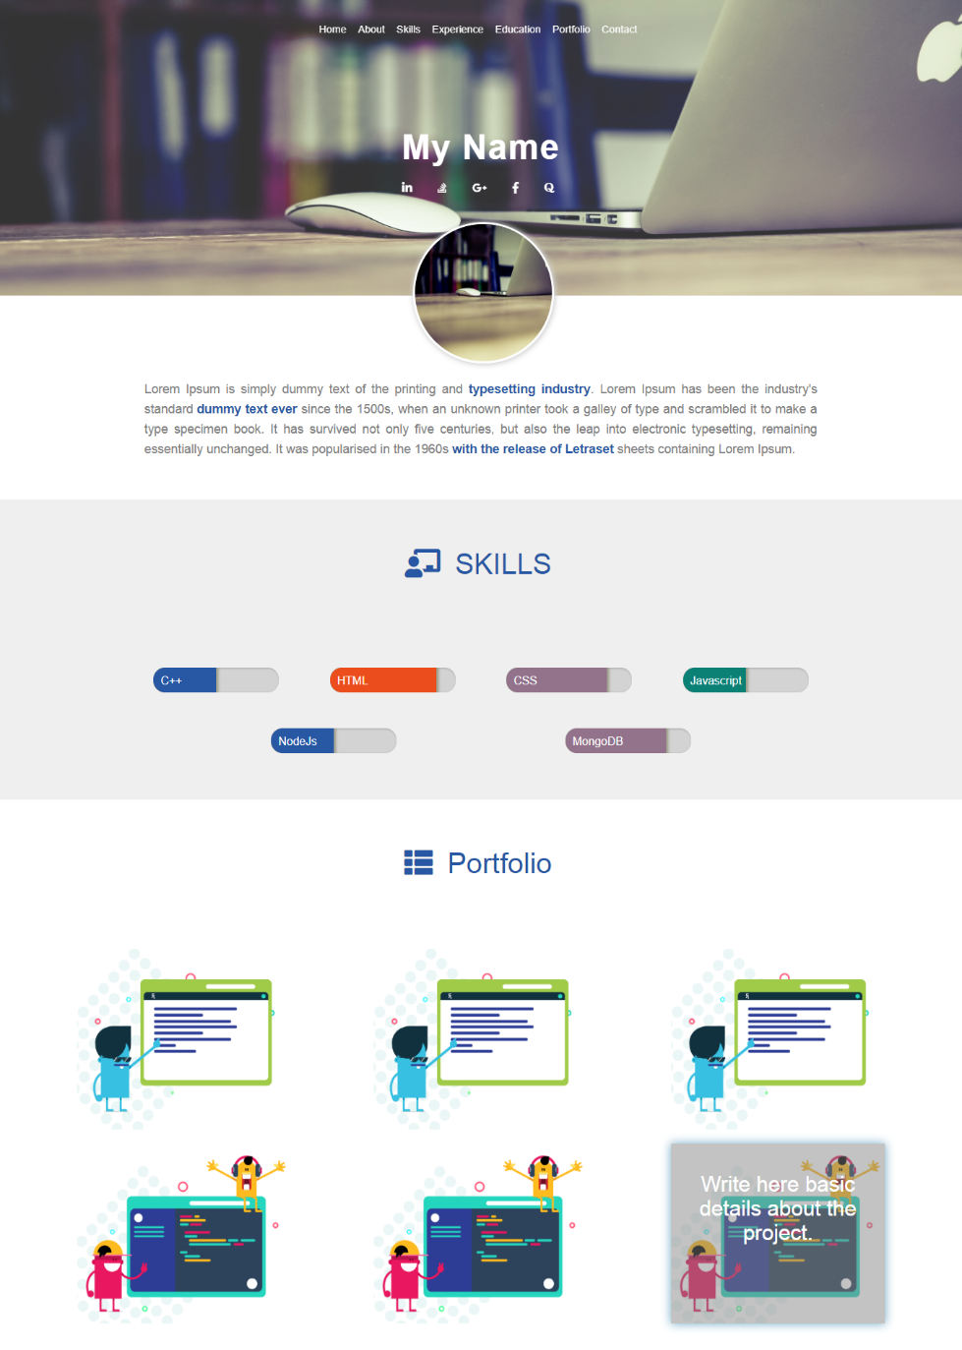

Images to be used are provided in assets. References for images used in video are -
1. https://ninjasfiles.s3.amazonaws.com/asset_0000000000000025_1550237330_codezen_2.png
2. https://ninjasfiles.s3.amazonaws.com/asset_0000000000000024_1550237299_codezen.png

